## Assignment - 4

Wowki & IBM Cloud

|  |  |
| --- | --- |
| Assignment Date | 13 November 2O22 |
| Student Name | Aparna K |
| Student Roll Number | 211719104018 |
| Maximum Marks | 2 Marks |

Question-l:

Write code and connections in wowki for the

sensor. Whenever the distance less

than l00cms sent "alert" to IBM cloud and

|display in device recent events.

### Code:

##### l #include <WiFi.h>

it i nc lude <P ubs ubC1 ien t . hb li i nc lude <A rdu i nozs on . h >

WiFiClient uifiClient; '

#define ORG "oa8490"

#define DEVICE_TYPE "TestDeviceType"

##### #define DEVICE_ID "12345"

#define TDKEN "-Al0raS44flfdj¥BVS" #define speed 0.034

l char server ] - 0R1 ".messaqing.internetofthings.ibmcloud.com"; '

##### char publishTopic[] - "iot-2/evt/abcd l/fms/json"; char topic[]

- " i oc - 2 / cv d/ hone / but /S t ri nq " i char an rhMe shod [ ] - " use- t o ken-

an t h" ; ch ar to ke n [ ] - T OKEN ;

char Cl1enzId[l - "d:" ORG ":" DEVICE_TYPE ":" PubSubClient client(server, 1883, wifiCiienz) ; publishDaza();

DEvdc I&:

const int trigpin=5; const int echopin=l3:

String command;

String data=“ “;

String lat=“l4. 167589“; String lon=“80.248510“;

String name="point2":

String icon="";

long duration; int dist;

vo i d z e r ap ( )

( Serial.b-gi (115200) ; p- ” :e(trigpin, OUTPUT)

p- +(echopin, lPUT) ; wifiConnect():

mqttConnect();



void loop() ( publishData();

- (500) ;

if (!client.loop()) ( mqXtZonectC;

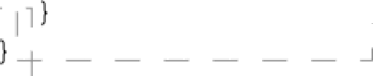

##### void wifi€onnect() (



Serial.; : :. ("Wifi") ; WiFi .h=j ("Wokwi—GUEST"

' ;_while WiF .status() != WL_C0NNECTED) (

r Se

ia1 . 1:• ( " . " ) ;

Serial.¿=-— (“WiFi connected, lP address : ") ;

Serial. : ( WiFi.localIP())



avoid mqttConnect{) (

' if (! client.connected()} (

**Serial.pr** n’( "Reconnecting MQTT client to ") ; I

Serial.p ›r l server); while {!client.connect(cli'entId,

authMethod, taken)

I i

( Serial.p =' (".") ;



’initManagedDevice(); Serial.p t_ ›_ u() ;

void initManagedDevice() (

if ( client.subscribe(topic)) ( '

Serial.pi : : .( client.subscri'be(topic));

Ser lal . › i i * i ( " s u bs cr ibe t o cmd OK " ) ;

): else {

Serial.p ’›’ › ("subscribe to cmd FAILED") ;

} ) void

publishData {)

( I’m’’ !W °’••(trigpin,LOW)

. a?’ !'i' ••(trigpin,HIGH) 

..,. .. .... =•..1... ,

q3’ !:< i_=(trigpin,LQW) ; dur0tion=pu.’c ’: (echopin,MIGM)

; dist=duration*speed/2; I

if(dist<100){

dist=l00- dist; icon="fa- trash";

**)else( distr:**

icon="fa-trasN-

 

 Dynami cJ s on Doc umen t doc ( 1 0 24 ) i

String payload; doc{"Name")= I

' name; docl"Latitude")= lat;

doc{"Longitude"]= lon; doc [ " I con " ] = icon; docl"FillPercent")= diet;

doc, payload);





Serial.p .’ ("lending payload: ") ; I

l Serial.p —.' .( payload): — I

' if (client.publish(publishTopic, (ohar’) payload.c_str()))

( Serial.p .' .(”Publish OK") ;

##### ) else l

' Serial.) .’ .("Publish FAILED") ; I

### Connecdons:

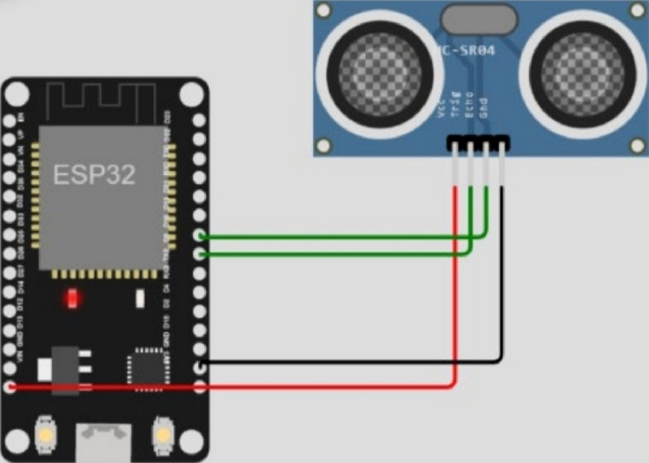

Output:

 WOK WI

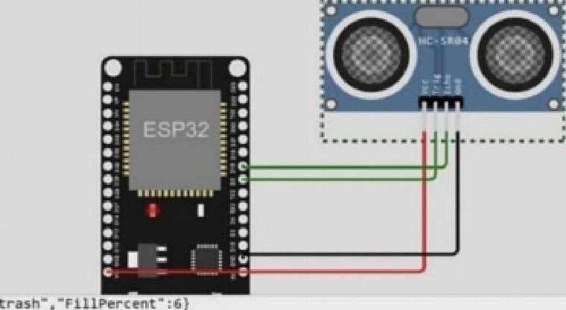

#### Output :( IBM Clo ud)

